A Hybrid Model for Evaluation of E-Learning User Satisfaction with TAM and ELQ Approach

Sina Sayardoost Tabrizi  Ph.D. Candidate of Industrial Management  The University of Guilan, Rasht, Iran  s.sayardoost@ut.ac.ir | Azin Sabzian  BSc of Computer Engineering  The University of Tehran, Kish, Iran  azin.sabzian@ut.ac.ir
Ali Moeini
School of Engineering Science, College of Engineering, Faculty
The University of Tehran, Tehran, Iran
moeini@ut.ac.ir

Abstract— With the start of the Coronavirus epidemic, remote education systems were widely accepted in all universities around the world. The University of Tehran, the top university in Iran, had an electronic education system since 2010, which provided services in this field to the academic community. With the spread of the pandemic, these services became widespread in all departments of the University of Tehran. Compared to traditional learning, E-Learning brings challenges for Users, the main challenge of which is Users’ Satisfaction. In this paper, by examining the developed model based on the TAM model and the factor analysis of this model, the level of satisfaction of student users with the e-learning management system of the University of Tehran during the Corona era is carefully evaluated. The exploitation of this model with the analytical method of partial least squares in the construction of structural equations is based on the information collected from the questionnaire that has been provided to the users of the e-learning system of the University of Tehran. The results obtained from this study show that the Technology Acceptance Model (TAM) describes well the factors affecting the level of user satisfaction with the E-learning management system. The positive effect of the visual beauty and the quality of the information in this system has improved the technical quality of the service; as a result, the level of user satisfaction in using this system has increased.

Keywords- user satisfaction, exploratory factor analysis, e-learning quality, technology acceptance model

Introduction
Covid-19 virus threatens the health of human beings worldwide, imposing a concern for the world [8]. To manage the contagion, many countries have implemented restrictive measures to reduce social gatherings and promote social distancing. This meant the closure of higher learning institutions and a major shift from traditional classroom-based teaching and learning to a virtual approach [2]. Therefore, the Covid-19 pandemic has dramatically affected the universities’ and schools’ teaching and learning experience. In response, governments and higher education institutions worldwide put significant efforts to ensure that students continue to obtain the best possible education and learning outcomes [2]. This caused educational centers to use distance education systems to continue the education process. Among the facilities that distance education systems have provided learning with an E-learning management system is the possibility of continuing education during the spread of the Coronavirus and facilitated student-teacher communication, especially in online classes.
It should be noted that e-learning management systems were rarely used to complete the educational process in the pre-coronavirus era, but with the spread of this disease around the world, the use of these systems is considered the main pillar of many schools, universities, and other educational centers.
Studies show that remote e-learning students feel secluded [10, 11], and often suffer in their studies due to the low levels of student-teacher interactivity [12], this encourages researchers to evaluate the users’ satisfaction with the E-learning management system. Additionally, E-learners' satisfaction significantly impacts the success of the e-learning process and improves the quality of the e-learning system [14]. By considering the developed model which is designed based on the technology acceptance model, this study aims to evaluate the factors affecting users' satisfaction with the e-learning management system of the University of Tehran to give the best services to users.
E-learning is fundamentally a web-based program that presents knowledge or information to learners readily on time regardless of time constraints or location proximity [3]. Quality in learning could be understood as a set of characteristics or attributes which are chosen for evaluating the service that affects consumer satisfaction, either implicitly or explicitly [1].

related work
challenges of online teaching and learning that Corona has brought to education have been studied in the literature presented by Zethembe Mseleku. The literature shows that, among others, academics’ and students’ difficulties to adjust; connectivity, network, and internet issues; unconducive physical space and environment; mental health-related issues; lack of basic needs; and lack of teaching and learning resources are the major challenges associated with the sudden change to online learning [13].
Due to a sudden COVID-19 outbreak and consequently, a sudden shift to online learning, ordinary academics did not have adequate time to adjust to the new teaching platforms [15]. Another challenge was difficulty in adjusting to online learning styles, having to perform responsibilities at home, and due to poor communication between them and lectures, students were generally not prepared for online learning [16]. Challenges with connectivity to the internet were highlighted as the leading factor undermining e-learning and e-teaching during g the lockdown as a result of the Covid-19 pandemic outbreak [1The lack of physical learning space and environment also presented itself as a challenge for some students learning online during lockdown [13]. Kapasia et al. found that about 44.4% of students had no separate reading room for the study. Without a conducive learning environment, students cannot concentrate on their schoolwork, and study productivity is reduced as a result [18,19].
Ahmad Mohammad Al-smadi, Ahed Abugabah and Ahmad Al Smadi’s study was carried out to determine the main elements and factors related to students’ satisfaction and quality of e-learning during the Covid-19 pandemic era based on various aspects and dimensions of e-learning. The main findings of the study indicated that students’ satisfaction and evaluation of the e-learning experience during the pandemic were not promising. Therefore, higher education institutions should reconsider their efforts and approaches to improve the quality of e-learning and the learning outcomes achieved. For example, they assumed that IT infrastructure, Internet access, and particularly network connectivity could be improved to fully support online courses [2].
a cross-sectional study was presented, which was conducted in 2020 among students studying in different fields of Qazvin University of Medical Sciences using stratified random sampling. To collect data three parts of questionnaires were used included the demographic information, the measuring the effectiveness of e-learning, and measuring the level of satisfaction with holding e-learning during the Covid-19 period. In this study, results were obtained using t-test. The results showed that the mean (standard deviation) score of satisfaction with e-learning in the students was 20.75 (2.13) and 59 % of them had undesirable satisfaction. There was a significant relationship between satisfaction with e-learning and variables of gender and history of attending online classes before Covid-19. [14]
Another study during the COVID-19 pandemic examines the role of technological skills, equipment capabilities, user satisfaction, and motivation on e-learning readiness. this study also examines the significance of the mediating role of motivation. The study adopted an ex-post-facto design involving 1052 students as participants. Data is collected from a questionnaire form integrated into the university's e-learning system. Analyzing the data using SEMPLS (which is a data analysis tool with a confidence interval of 97.5%) technology skills, equipment capabilities, user satisfaction, and motivation are proven to play a role in e-learning readiness. The study's results further clarify that efforts to improve e-learning readiness require digital technology capabilities, equipment capabilities, user satisfaction, and motivation, so vocational education must strengthen these aspects. [9]

Research method and variables
An analytical method has been used for a case study by collecting data through the survey questionnaire Elearn system questionnaire.htm filled out by the University of Tehran students who used the E-learn management system. The correlation coefficients of the parameters introduced in the proposed model are evaluated to identify the factors affecting the level of user satisfaction with the e-learning management system of the University of Tehran. The effect of 12 factors was investigated as factors affecting users’ satisfaction. The relationships between these factors were presented by a proposed model. With the use of SmartPLS and Gpower software, we calculated the random sample size and evaluated the proposed model's factor loadings. The reason for selecting the University of Tehran students is to have a large number of students with different ages and educational levels so that the best results can be obtained from the proposed model.
The collected data has been evaluated based on the Exploratory Factor Analysis (EFA) method and using structural equations of variance based (PLS-SEM) under SmartPLS software. The number of filled questionnaires was 145 cases of electronic learning system users of the University of Tehran who are studying under the title of students. The basic concept which is used in the paper are reviewed in the next section.

TAM-Based Model
A model based on the technology acceptance model is used, which has been used in many scientific articles. In this model, the attitude variable expresses people's positive and negative opinions of using this system, which indicates the level of understanding of the ease of use and also the level of perceived usefulness of using the system [6]. This understanding of the ease of use and usefulness of using the system directly impacts users’ behavioral performance in using electronic education systems. In this study, the facilitating conditions have been introduced as an effective factor in the perceived usefulness in such a way that the more the facilitating conditions are provided for the students, the more useful the system will be for them. Also, the users’ technical knowledge level has been introduced as an effective factor in understanding the user's ease of use of the system. Students who have higher technical knowledge can use the system more easily.

SERVQUAL:
The concept and perception of quality are explained through the SERVQUAL model suggested by Parasuraman, Zeithaml, and Berry (1988), which has Expectation Confirmation Theory (Oliver, 1980) in its base. SERVQUAL objective is to measure the gap between consumer expectation and experience, i.e. a perception of satisfaction, concerning the services provided; and relies on the essential supposition that clients can assess the service quality of an organization by contrasting their expectations and experiences [4]. SERVQUAL stands out from other instruments, utilized to measure service quality, due to the distinctive methodologies that can be utilized for plugging gaps; i.e. SERVQUAL has been applied in both theoretical and operational domains [5].
In this article, the effect of the appearance quality of the system and the quality of the information provided in the system is considered as an effective factor in the technical quality of the service, improving the quality of the website’s appearance in addition to the high quality of the information in the system is ultimately effective on the level of user satisfaction with the system in the time of Coronavirus.

proposed model
To evaluate the level of user satisfaction with the e-learning management system, as a target variable, the performance of the e-learning management system at the University of Tehran has been investigated. In this sense, the TAM model according to Figure1 has been used as the proposed model. In this proposed model, appearance quality and information quality are introduced as two effective external factors in the technical quality of the service. The appearance quality of the E-learn management system includes things that improve the beauty and attractiveness of the system and the e-learning site, and the quality of the system information is introduced as an important factor in the model, this information is available to the users who use the system. The two factors, appearance quality and the information quality of the e-learn management system have both been effective in the technical quality of the service, which had a high impact on user satisfaction with the E-learn management system of the University of Tehran at the time of the Coronavirus. All these factors have been raised as questions in the electronic questionnaire and then evaluated in the proposed model.

Hypothesis
According to Figure 1, hypothesis 1 (H1) is defined as follows: facilitating conditions have a relationship with the perceived usefulness and are effective on it, and according to hypothesis 2 (H2), these facilitating conditions have a relationship with understanding the ease of use of the system. In the same way, we define that hypotheses 3 and 4 (H3 and H4) respectively state that the people’s technical knowledge level has a transitory effect on the understanding of the ease of use and attitude. The continuation of hypotheses 5 and 6 (H5 and H6), respectively shows that understanding the level of ease of use is related to perceived usefulness (utility) and attitude. The relationship between the perceived ease of use and the person's attitude, which includes his/her positive or negative feelings toward the system, is considered hypothesis 7 (H7), and the relationship between perceived usefulness and behavioral intention is considered as hypothesis 8 (H8), which of course is considered as a correlation between those two factors. The nesting of these factors was examined and analyzed. Also, the relationship between attitude and behavioral intentions has been considered as hypothesis 9 (H9), and the effect of behavioral intentions on the target factor, which was the user satisfaction level in using the system during the Corona pandemic, has been considered as hypothesis 10 (H10). According to the 11th hypothesis (H11), people's attitudes toward the system will also affect the target variable. Next, hypotheses 12, 13, and 14, are introduced. According to hypotheses 12 and 13 (H12, H13), respectively, the appearance quality of the system and the quality of the information provided to users in this system are considered as two factors affecting the technical quality of this system. Finally, by introducing hypothesis 14 (H14), we show that this level of technical quality affects the target variable, which is the level of user satisfaction with the e-learning management system of the University of Tehran.
Overall, 14 hypotheses were introduced and reviewed in this study, and all of them were introduced to check the level of user satisfaction. (figure 1)

Figure 1: TAM model and hypotheses

Data collection
In this research, SmartPLS software was used to evaluate the proposed model's factor loadings and measure each factor's impact. Also, a questionnaire has been used that presents the factors affecting the basic model based on TAM along with some additional indicators and defines the target community by taking into account the collected demographic information.
In this study, participants were randomly selected,145 University of Tehran's e-learning management system users have completed this questionnaire at different times. A summary of the analysis of the target community is prepared in the following charts based on the collected data.
48% of women and 52% of men make up this statistical population who have participated in the proposed questionnaire, whose age range is shown in chart 3. 23% of the participants were in the age range of 15-20, 32% of them were in the age range of 21-30, 39% in the age range of 31-45 and 6% of them were over 45 years old.
One of the factors that makes the model proposed in this research reliable is considering the total number of students with various educational backgrounds. Students studying in the fields of art and architecture, basic sciences, human sciences, technical and engineering, as well as medical and experimental sciences in associate, bachelor's, master's, and doctoral degrees have participated in the proposed questionnaire. Diagrams 4 and 5.
According to the data collected from the statistical community, the users of this system have used different internet platforms to access the University of Tehran's e-learning management system, which is shown in diagram 6. These communication platforms have varied from Mobile Data Internet, Mobinnet Internet, LTE, and ADSL.
The users of the University of Tehran's E-learn electronic system have used different systems to access this system, which is shown in diagram 7. According to this chart, the majority of students have used laptops to access the E-learn management system.

evaluation
This questionnaire evaluates the target community of this field study by considering 44 key indicators in addition to 6 analytical questions. In the structural model (figure 2) obtained from the software, several 10 reflective structures are introduced, and each key index is considered as a subset of these structures. As shown in figure 2, three indicators, FC1, FC2, and TK4, have been removed from the model due to their low correlation with their observed variable, to obtain the best result from the path coefficients. Finally, the number of key indicators was reduced to 41. In the structural model shown in figure 1, if the obtained each number estimated from correlations between variables was greater than 1.96, it shows a significant level of correlation between the variables of the structure. As the results obtained from Table 1 show, the average variance extracted for all constructs was calculated to be higher than 0.5, which describes the accuracy of measuring the variables and the reliability of the proposed model.
In this article, a questionnaire with 50 questions and also a Google Form service were used to collect data. Our goal is to provide a model based on which we can estimate the level of user satisfaction according to our combined criteria and determine the most important factors on user satisfaction. The collected data was implemented with Excel software and then after preparation was used as input in SmartPLS software. Gpower software was used to calculate the sample size.
In this research, the effect size is 0.235 and the probability of alpha error is 0.05, and the power of the test is 0.8. After performing calculations in Gpower software, the sample size is estimated to be 145. By examining the effect of factor loadings and the degree of correlation between observed and latent variables, as well as measuring the combined reliability and

Latent Variable | Observed Variable | Factor Loading | Cronbach's Alpha | rho_A | Composite Reliability | Average Variance Extracted (AVE)
Technical Knowledge | TK1  TK2  TK3  TK5 | 0.741  0.888  0.873  0.861 | 0.863 | 0.876 | 0.907 | 0.710
Perceived Ease Of Use | PEU1  PEU2  PEU3  PEU4 | 0.889  0.835  0.833  0.837 | 0.870 | 0.872 | 0.912 | 0.720
User Satisfaction | SUE1  SUE2  SUE3  SUE4 | 0.874  0.868  0.881  0.754 | 0.866 | 0.873 | 0.909 | 0.716
Appearance Quality | AQ1  AQ2  AQ3  AQ4 | 0.896  0.911  0.931  0.882 | 0.926 | 0.927 | 0.948 | 0.819
Perceived Usefulness | PU1  PU2  PU3  PU4 | 0.910  0.873  0.909  0.971 | 0.924 | 0.925 | 0.946 | 0.815
Facilitating Conditions | FC3 | 1.000 | 1.000 | 1.000 | 1.000 | 1.000
Behavioral Intention | BI1  BI2  BI3  BI4  BI5 | 0.946  0.954  0.951  0.722  0.855 | 0.932 | 0.941 | 0.950 | 0.792
Attitude | AT1  AT2  AT3  AT4 | 0.907  0.825  0.888  0.722 | 0.857 | 0.877 | 0.904 | 0.704
Information Quality | IQ1  IQ2  IQ3  IQ4 | 0.900  0.889  0.929  0.849 | 0.914 | 0.916 | 0.940 | 0.796
Service Quality | SRV1  SRV2  SRV3  SRV4  SRV5  SRV6  SRV7 | 0.721  0.822  0.862  0.823  0.858  0.825  0.830 | 0.919 | 0.925 | 0.935 | 0.675
Table 1: construct reliability and validity

validity of the proposed model [7], a reliable output is obtained (as shown in Table 1). The measurement of factor loadings shows the degree of correlation of each construct with itself as well as the convergence between the constructs, this convergence has been measured by considering Cronbach's alpha and composite reliability [7]. In Table 1, Cronbach's alpha value is at least 0.857 for the latent variable of attitude and the composite reliability value is 0.912 for the latent variable of perceived ease of use. Validity measurement in this research shows that its minimum
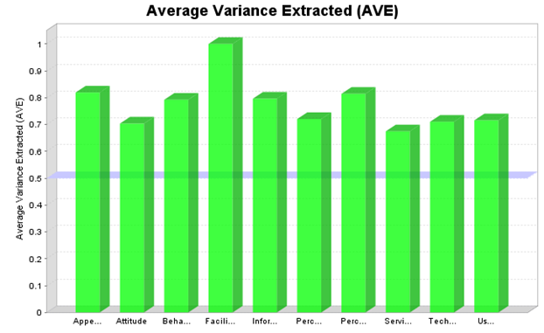 Figure 3: Average Variance Extracted

value is 0.704 and belongs to the latent variable of attitude. As can be seen in Figure 2, the proportional validity criterion obtained from this proposed model shows the internal consistency as well as the strength of the relationship between the indicators in the proposed model.

Discriminant Validity:
The use of SmartPLS software allows us to ensure the authenticity of the data collected from the questionnaire. After collecting the data, it is time to measure the validity of the data. Validity means that the researcher's tool can accurately evaluate the subject being measured. This validity is the most important indicator for measuring the quality of the proposed model. Construct validity is classified into two parts: divergent and convergent validity. According to Fornell Larcker's report shown in Table 2, the value of validity obtained from the proposed model for each construct should be less than the variance of the total constructs. Table 2 shows a triangular matrix, the values ​​in the diameter of this triangular include a larger value than the number shown in each row. It indicates that in this study there is a proportional validity between the manifest variables and their latent variables. Also, this validity shows us favorable results when the factor load of an index in one construct is more than in other constructs. This issue in Table 3 is displayed. As shown in Table 3, the factor load of each index for each construct shows the highest value compared to other constructs, which shows the correctness of the correlation of manifest and latent variables in this proposed model. Additionally, Table 4 shows the ratio of HTMT, differential validity problems are significant when their values are higher than 0.9.

To evaluate the path coefficients between observed and latent variables, a bootstrapped algorithm with 5000 samples and a significance level of 5% was used and the results of which can be seen in Table 6 and Figure 2. Table 6 shows the relationship between the two independent variables that are connected and the 14 hypotheses of this article, which were introduced according to Figure 1, and was investigated by the t-hypothesis test, and its p-value was reported. As the results show in Table 6, Samples with a P-value less than 0.05 or a T-statistic value greater than 1.96 have a significant relationship, and if the calculated values ​​for these two parameters do not fall within this range, there is not a significant relationship between the two independent variables in the proposed model.

For instance, the path between Appearance Quality and Service Quality shows a significant relationship. This is because it has a P-value less than 0.05 and a T-static value greater than 1.96. We can see that the paths which have a P-value more than 0.05 or a T-statistics value less than 1.96 do not show a significant relationship.

Determination factor R²:
This coefficient can be used to measure the prediction accuracy of the proposed model. The value of this coefficient can be predicted by the observed variable in examining the relationship between observed and latent variables. This coefficient is the output value of the regression analysis, which is used as the variance ratio between the latent variables. This coefficient can also be defined as the square of the correlation coefficient between the variables. The values ​​of this coefficient can be between zero and one variable (figure 3). In Table 5, R² coefficients belonging to the variables of the proposed model are prepared.
As shown in Table 5, if the value of this coefficient is less than 0.25, it indicates a weak correlation between the variables, if it is in the range of 0.25 to 0.75, it indicates an average correlation, and finally, if the value of the coefficient is more than 0.75, it indicates a strong correlation between the structure variables.

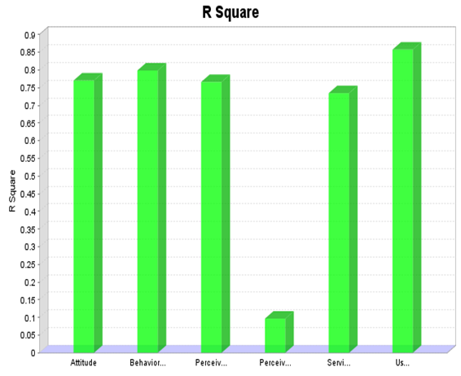Figure 4: R Square

F² effect size:
This statistical parameter can be used to measure the accuracy of the relationship between observed and latent variables. According to the proposed model, 13 relationships between latent variables have been reported, and the values ​​of the F² effect size are given in Table 7. The sum of these values ​​indicates the amount of this effect in terms of the variables, as the results show in Figure 4, 0.02 is low impact, 0.15 is moderate impact, and finally, 0.35 value indicates the large effect size of this statistical parameter.
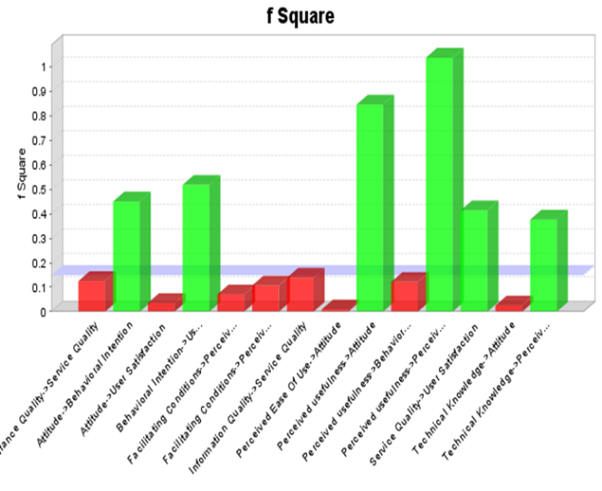
figure 5: F Square

Table 2: Fornell Larcker
Service Quality | Information Quality | Attitude | Behavioral Conditions | Facilitating Conditions | Perceived Usefulness | Appearance Quality | User Satisfaction | Perceived Ease of Use | Technical Knowledge
 |  |  |  |  |  |  |  |  | 0.843 | Technical Knowledge
 |  |  |  |  |  |  |  | 0.849 | 0.687 | Perceived Ease of Use
 |  |  |  |  |  |  | 0.846 | 0.824 | 0.690 | User Satisfaction
 |  |  |  |  |  | 0.905 | 0.629 | 0.569 | 0.550 | Appearance Quality
 |  |  |  |  | 0.903 | 0.469 | 0.838 | 0.802 | 0.507 | Perceived Usefulness
 |  |  |  | 1.000 | 0.311 | 0.422 | 0.363 | 0.425 | 0.305 | Facilitating Conditions
 |  |  | 0.890 | 0.275 | 0.841 | 0.450 | 0.880 | 0.738 | 0.538 | Behavioral Intention
 |  | 0.839 | 0.880 | 0.330 | 0.868 | 0.485 | 0.848 | 0.758 | 0.544 | Attitude
 | 0.892 | 0.555 | 0.507 | 0.407 | 0.579 | 0.905 | 0.660 | 0.613 | 0.517 | Information Quality
0.821 | 0.837 | 0.611 | 0.553 | 0.510 | 0.600 | 0.835 | 0.719 | 0.632 | 0.569 | Service Quality

Figure 2: Structural model
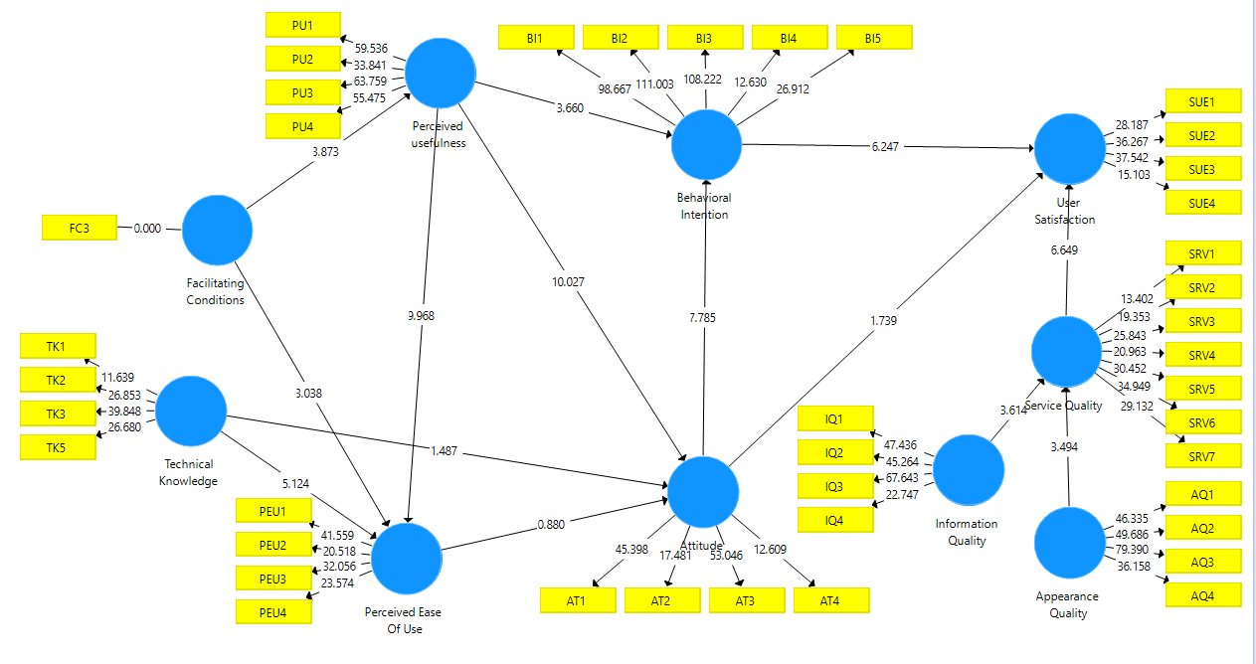

Table 5: R Square

Correlation | R Square
STRONG | 0.766 | Perceived Ease of Use
STRONG | 0.858 | User Satisfaction
WEAK | 0.097 | Perceived Usefulness
STRONG | 0.799 | Behavioral Intention
STRONG | 0.770 | Attitude
STRONG | 0.734 | Service Quality

Table 6: Path Co-efficiency
 | Original Sample (O) | Sample Mean (M) | Standard Deviation (STDEV) | T Statistics (|O/STDEV|) | P Values | Significant
Appearance Quality => Service Quality | 0.427 | 0.425 | 0.122 | 3.494 | 0.000 | Yes
Attitude => Behavioral Intention | 0.607 | 0.609 | 0.078 | 7.785 | 0.000 | Yes
Attitude => User Satisfaction | 0.158 | 0.157 | 0.091 | 1.739 | 0.082 | No
Behavioral Intention => User Satisfaction | 0.572 | 0.573 | 0.092 | 6.247 | 0.000 | Yes
Facilitating Conditions => Perceived Ease Of Use | 0.138 | 0.135 | 0.045 | 3.038 | 0.002 | Yes
Facilitating Conditions => Perceived usefulness | 0.311 | 0.308 | 0.080 | 3.873 | 0.000 | Yes
Information Quality => Service Quality | 0.451 | 0.454 | 0.125 | 3.614 | 0.000 | Yes
Perceived Ease Of Use => Attitude | 0.090 | 0.094 | 0.103 | 0.880 | 0.379 | No
Perceived usefulness => Attitude | 0.742 | 0.738 | 0.074 | 10.027 | 0.000 | Yes
Perceived usefulness => Behavioral Intention | 0.315 | 0.312 | 0.086 | 3.660 | 0.000 | Yes
Perceived usefulness => Perceived Ease Of Use | 0.582 | 0.580 | 0.058 | 9.968 | 0.000 | Yes
Service Quality => User Satisfaction | 0.307 | 0.306 | 0.046 | 6.649 | 0.000 | Yes
Technical Knowledge => Attitude | 0.106 | 0.106 | 0.071 | 1.487 | 0.137 | No
Technical Knowledge > Perceived Ease Of Use | 0.350 | 0.355 | 0.068 | 5.124 | 0.000 | Yes

Table 3: Cross loadings

Service Quality | Information Quality | Attitude | Behavioral Intention | Facilitating Conditions | Perceived Usefulness | Appearance Quality | User Satisfaction | Perceived Ease Of Use | Technical Knowledge
0.543 | 0.537 | 0.907 | 0.785 | 0.293 | 0.819 | 0.450 | 0.786 | 0.732 | 0.490 | AT1
0.519 | 0.432 | 0.825 | 0.685 | 0.151 | 0.648 | 0.379 | 0.669 | 0.585 | 0.462 | AT2
0.531 | 0.441 | 0.888 | 0.866 | 0.275 | 0.831 | 0.369 | 0.784 | 0.662 | 0.423 | AT3
0.455 | 0.458 | 0.722 | 0.582 | 0.411 | 0.577 | 0.447 | 0.583 | 0.549 | 0.467 | AT4
0.487 | 0.460 | 0.859 | 0.946 | 0.260 | 0.793 | 0.410 | 0.817 | 0.697 | 0.494 | BI1
0.506 | 0.426 | 0.853 | 0.954 | 0.233 | 0.809 | 0.362 | 0.810 | 0.704 | 0.511 | BI2
0.523 | 0.471 | 0.852 | 0.951 | 0.291 | 0.805 | 0.412 | 0.836 | 0.690 | 0.463 | BI3
0.516 | 0.524 | 0.639 | 0.722 | 0.244 | 0.630 | 0.467 | 0.732 | 0.616 | 0.527 | BI4
0.429 | 0.383 | 0.684 | 0.855 | 0.192 | 0.688 | 0.361 | 0.712 | 0.566 | 0.404 | BI5
0.510 | 0.407 | 0.330 | 0.275 | 1.000 | 0.311 | 0.422 | 0.363 | 0.425 | 0.305 | FC3
0.791 | 0.900 | 0.532 | 0.490 | 0.379 | 0.523 | 0.839 | 0.618 | 0.542 | 0.482 | IQ1
0.727 | 0.889 | 0.418 | 0.390 | 0.310 | 0.426 | 0.863 | 0.539 | 0.470 | 0.422 | IQ2
0.754 | 0.929 | 0.539 | 0.474 | 0.359 | 0.572 | 0.822 | 0.610 | 0.587 | 0.470 | IQ3
0.713 | 0.849 | 0.488 | 0.451 | 0.404 | 0.542 | 0.701 | 0.585 | 0.588 | 0.471 | IQ4
0.524 | 0.519 | 0.588 | 0.562 | 0.297 | 0672 | 0.481 | 0.705 | 0.889 | 0.687 | PEU1
0.505 | 0.519 | 0.59 | 0.574 | 0.341 | 0.644 | 0.434 | 0.642 | 0.835 | 0.578 | PEU2
0.566 | 0.503 | 0.732 | 0.738 | 0.417 | 0.757 | 0.500 | 0.745 | 0.833 | 0.500 | PEU3
0.543 | 0.539 | 0.644 | 0.617 | 0.384 | 0.641 | 0.511 | 0.696 | 0.837 | 0.572 | PEU4
0.519 | 0.489 | 0.776 | 0.709 | 0.320 | 0.910 | 0.396 | 0.708 | 0.697 | 0.436 | PU1
0.504 | 0.514 | 0.759 | 0.734 | 0.268 | 0.873 | 0.411 | 0.775 | 0.708 | 0479 | PU2
0.580 | 0.536 | 0.794 | 0.770 | 0.285 | 0.909 | 0.445 | 0.745 | 0.728 | 0.428 | PU3
0.561 | 0.548 | 0.804 | 0.820 | 0.252 | 0.917 | 0.439 | 0.795 | 0761 | 0.486 | PU4
0.757 | 0.805 | 0.431 | 0.413 | 0.350 | 0.404 | 0.896 | 0.567 | 0.492 | 0.531 | SQ1
0.709 | 0.803 | 0.396 | 0.393 | 0.310 | 0.404 | 0.911 | 0.570 | 0.514 | 0.475 | SQ2
0.777 | 0.840 | 0.464 | 0.141 | 0.399 | 0.471 | 0.931 | 0.592 | 0.568 | 0.520 | SQ3
0.777 | 0.824 | 0.459 | 0.407 | 0.462 | 0.414 | 0.882 | 0.547 | 0.484 | 0.464 | SQ4
0.721 | 0.685 | 0.424 | 0.433 | 0.391 | 0.510 | 0.626 | 0.551 | 0.552 | 0.492 | SRV1
0.822 | 0.577 | 0.493 | 0.372 | 0.382 | 0.435 | 0.573 | 0.483 | 0.409 | 0.352 | SRV2
0.862 | 0.664 | 0.472 | 0.415 | 0.462 | 0.458 | 0.647 | 0.520 | 0.425 | 0.375 | SRV3
0.823 | 0.565 | 0.505 | 0.420 | 0.407 | 0.454 | 0.618 | 0.517 | 0.449 | 0347 | SRV4
0.858 | 0.794 | 0.534 | 0.490 | 0.416 | 0.500 | 0.796 | 0.665 | 0.579 | 0.555 | SRV5
0.825 | 0.717 | 0.507 | 0.485 | 0.474 | 0.507 | 0.714 | 0.649 | 0.585 | 0.519 | SRV6
0.830 | 0.750 | 0.557 | 0.524 | 0.396 | 0.559 | 0.767 | 0.686 | 0.578 | 0.564 | SRV7
0.620 | 0.500 | 0.686 | 0.723 | 0.271 | 0.675 | 0.524 | 0.874 | 0.703 | 0.663 | SUE1
0.722 | 0.688 | 0.691 | 0.705 | 0.412 | 0.719 | 0.667 | 0.868 | 0.763 | 0.651 | SUE2
0.581 | 0.545 | 0.827 | 0.857 | 0.290 | 0.833 | 0.472 | 0.881 | 0.753 | 0.512 | SUE3
0.507 | 0.496 | 0.654 | 0.681 | 0.252 | 0.587 | 0.466 | 0.754 | 0.552 | 0.515 | SUE4
0.398 | 0.324 | 0.471 | 0.471 | 0.258 | 0.452 | 0.286 | 0.535 | 0.524 | 0.741 | TK1
0.431 | 0.389 | 0.368 | 0.370 | 0.238 | 0.355 | 0.416 | 0.491 | 0.527 | 0.888 | TK2
0.603 | 0546 | 0.567 | 0.546 | 0.297 | 0.492 | 0.620 | 0.701 | 0.676 | 0.873 | TK3
0.447 | 0.451 | 0.367 | 0.392 | 0.221 | 0.382 | 0.487 | 0.557 | 0.555 | 0.861 | TK5

Table 3: HTMT

Service Quality | Information Quality | Attitude | Behavioral Intention | Facilitating Conditions | Perceived Usefulness | Appearance Quality | User Satisfaction | Perceived Ease Of Use | Technical Knowledge
 |  |  |  |  |  |  |  |  |  | Technical Knowledge
 |  |  |  |  |  |  |  |  | 0.787 | Perceived Ease Of Use
 |  |  |  |  |  |  |  | 0.942 | 0.788 | User Satisfaction
 |  |  |  |  |  |  | 0.703 | 0632 | 0.600 | Appearance Quality
 |  |  |  |  |  | 0.505 | 0.931 | 0.891 | 0.599 | Perceived Usefulness
 |  |  |  |  | 0.324 | 0.437 | 0.390 | 0.454 | 0.324 | Facilitating Conditions
 |  |  |  | 0.285 | 0.905 | 0.489 | 0.980 | 0.816 | 0.593 | Behavioral Conditions
 |  |  | 0.973 | 0.365 | 0.965 | 0.550 | 0.976 | 0.871 | 0.626 | Attitude
 |  | 0.629 | 0.553 | 0.426 | 0.629 | 0.982 | 0.741 | 0.688 | 0.572 | Information Quality
 | 0.901 | 0.685 | 0.593 | 0.531 | 0.645 | 0.892 | 0.794 | 0.694 | 0.614 | Service Quality

Table 4: F Square
 | Appearance Quality | Attitude | Behavioral Intention | Facilitating Conditions | Information Quality | Perceived Ease Of Use | Perceived usefulness | Service Quality | Technical Knowledge | User Satisfaction
Appearance Quality | 0.000 | 0.000 | 0.000 | 0.000 | 0.000 | 0.000 | 0.000 | 0.125 | 0.000 | 0.000
Attitude | 0.000 | 0.000 | 0.450 | 0.000 | 0.000 | 0.000 | 0.000 | 0.000 | 0.000 | 0.036
Behavioral Intention | 0.000 | 0.000 | 0.000 | 0.000 | 0.000 | 0.000 | 0.000 | 0.000 | 0.000 | 0.517
Facilitating Conditions | 0.000 | 0.000 | 0.000 | 0.000 | 0.000 | 0.071 | 0.107 | 0.000 | 0.000 | 0.000
Information Quality | 0.000 | 0.000 | 0.000 | 0.000 | 0.000 | 0.000 | 0.000 | 0.139 | 0.000 | 0.000
Perceived Ease Of Use | 0.000 | 0.009 | 0.000 | 0.000 | 0.000 | 0.000 | 0.000 | 0.000 | 0.000 | 0.000
Perceived usefulness | 0.000 | 0.845 | 0.121 | 0.000 | 0.000 | 1.037 | 0.000 | 0.000 | 0.000 | 0.000
Service Quality | 0.000 | 0.000 | 0.000 | 0.000 | 0.000 | 0.000 | 0.000 | 0.000 | 0.000 | 0.414
Technical Knowledge | 0.000 | 0.025 | 0.000 | 0.000 | 0.000 | 0.376 | 0.000 | 0.000 | 0.000 | 0.000
User Satisfaction | 0.000 | 0.000 | 0.000 | 0.000 | 0.000 | 0.000 | 0.000 | 0.000 | 0.000 | 0.000

conclusion
In this research, a questionnaire was prepared for the users of Tehran University's LMS system and the effect of 12 factors on user satisfaction was investigated. 3 factors of Service Quality, Appearance Quality, and Information Quality in addition to 6 factors of Attitude, Behavioral Intentions, Perceived Usefulness, Facilitating Conditions, Technical Knowledge, and Perceived Ease of Use were investigated as factors affecting user satisfaction. The relationships between these factors were presented by a proposed model. By using SmartPLS and Gpower software, we concluded that the random sample size was correctly selected and the proposed model's factor loadings were evaluated. As shown in Table 6, hypotheses 11, 6, and 4 are not significant t; therefore, they are rejected and the rest of the hypotheses are significant and confirmed. We conclude that this structural model correctly displays the factors affecting user satisfaction based on the TAM and ELQ models.
This model was checked on the case of our current professorship, which was the E-Learning management system of the University of Tehran, and it gave these results. the results of this model will definitely be different for other universities. This is because the electronic education system of each university is different from the others, and most importantly, the audience of this system in every university has people with different backgrounds and fields of study.
Therefore, our model showed that it can well determine the influencing parameters in user satisfaction.
It is possible that the coefficient of influence of these parameters in the proposed model is different for other universities
Among future works, this model can be measured in other universities and compare its results and draw conclusions among Iranian universities, or it can be completed by developing the indicators of the proposed model.

References
[1] Veeramanickam M．R．M.,2022, Analysis on quality of learning in e-Learning platforms, advances in engineering software, volume 172, 10168
[2] Ahmad Mohmmad Al-smadi, Ahed Abugabah and Ahmad Al Smadi, 2022, Evaluation of E-learning Experience in the Light of the Covid-19 in Higher Education, procedia computer science, volume 201, Pages 383-389.
[3] Z-table.com. T value table - Z score table. Retrieved July 14, 2021, from. http://www.z -table.com/t-value-table.html.
[4] M. Amaad Uppal, Addressing Student Perception of E-learning Challenges in Higher Education Holistic Quality Approach, HENLEY BUSINESS SCHOOL THE UNIVERSITY OF READING,
[5] Buttle, 1996; Asubonteng, McCleary, & Swan, 1996
[6] Mailizar, M., Almanthari, A., Maulina, S., Bruce, S., 2020. Secondary school mathematics teachers’ views on E-learning implementation barriers during the COVID-19 pandemic: the case of Indonesia. Eurasia J. Math. Sci. Technol. Educ. 16 (7), em186.
[7] Hair, J.F., Risher, J.J., Sarstedt, M., Ringle, C.M., 2019. When to use and how to report the results of PLS-SEM. Eur. Bus. Rev. 31 (1), 2–24.
[8] Saeed Yousefi a, Hadi Shabanpour b, Kian Ghods c, Reza Farzipoor Saen, 2023, How to improve the future efficiency of Covid-19 treatment centers? A hybrid framework combining artificial neural network and congestion approach of data envelopment analysis, Computers & Industrial Engineering, page1.
[9] Wagiran, Suharjana, Muhammad Nurtanto, Farid Mutohhari, 2022, Determining the e-learning readiness of higher education students: A study during the COVID-19 pandemic, Heliyon, volume 8, issue number 10.
[10] G. Walker,Critical thinking in asynchronous discussions, International Journal of Instructional Technology and Distance Learning, 2 (6) (2005), pp. 15-22
[11] M. Hambali, Student and lecturer response on the implementation of line learning, ISCE: J. Innov. Stud. Charact. Educ., 4 (2) (2020), pp. 160-171
[12] J.B. Arbaugh, Virtual classroom characteristics and student satisfaction with internet-based MBA courses, J. Manag. Educ., 24 (1) (2000), pp. 32-54
[13] Zethembe Mseleku, 2020, A Literature Review of E-Learning and E-Teaching in the Era of Covid-19 Pandemic, International Journal of Innovative Science and Research Technology, Volume 5, Issue 10, page3.
[14] Leili Yekefallah, Peyman Namdar, Rahman Panahi, Leila Dehghankar, 2021, Factors related to students' satisfaction with holding e-learning during the Covid-19 pandemic based on the dimensions of e-learning, Heliyon, volume7, issue7.
[15] Burgess, Simon, and Hans Henrik Sievertsen. "Schools, skills, and learning: The impact of COVID-19 on education." VoxEu. org 1 (2020).
[16] Ronnie E. Baticulon, Nicole Rose I. Alberto, Maria Beatriz C. Baron, Robert Earl C. Mabulay, Lloyd Gabriel T. Rizada, Jinno Jenkin Sy, Christl Jan S. Tiu, View ORCID ProfileCharlie A. Clarion, John Carlo B. Reyes,2020, Barriers to online learning in the time of COVID-19: A national survey of medical students in the Philippines, medRxiv.
[17] Aboagye, Emmanuel, Joseph Anthony Yawson, and Kofi Nyantakyi Appiah, 2020, COVID-19 and E-learning: The challenges of students in tertiary institutions, Social Education Research.
[18] Nanigopal Kapasia, P. Paul, Avijit Roy, Jay Saha, A. Zaveri, Rahul Mallick, Bikash Barman, P. Das, P. Chouhan, 2020, Impact of lockdown on learning status of undergraduate and postgraduate students during COVID-19 pandemic in West Bengal, India, Children and Youth Services Review.
[19] Chang, Chiu-Lan, and Ming Fang, E-Learning and Online Instructions of Higher Education during the 2019 Novel Coronavirus Diseases (COVID-19) Epidemic, Journal of Physics: Conference Series, vol. 1574, no. 1, p. 012166. IOP Publishing, 2020.

