Optimal power allocation strategy for a D2D network based safety-critical V2X communication with partial CSI

Javad Zeraatkar Moghaddam

dept. of Electrical and Computer Engineering

University of Birjand

Birjand, Iran

javad.zeraatkar.m@birjand.ac.ir

Mehrdad Ardebilipour

dept. of Electrical Engineering

K. N. Toosi University

Tehran, Iran

mehrdad@eetd.kntu.ac.ir

Abstract—In intelligent transport system (ITS) networks, it is very useful to reduce the transmission energy consumption. Device-to-device (D2D) communication is a key technology that can improve the performance of the ITS networks. In this paper, we investigate a D2D-enabled vehicular network and study a power allocation strategy to maximize the spectral efficiency of the network. Also, for safety-critical vehicle-to-vehicle (V2V) and vehicle-to-infrastructure (V2I) applications, it is presented a reliable connection during the V2V and V2I links. The performance analysis of the investigated network shows that the studied method can maximize the total spectral efficiency of the network subject to satisfy some constraints when the channel state information (CSI) is perfectly known or not.

Keywords-vehicular communications; D2D communications; resource allocation; intelligent transport system; spectral efficiency.

# Introduction (Heading 1)

Vehicular ad-hoc networks (VANETs) have been suggested as a specific kind of Mobile ad-hoc network (MANET), so that groups of moving or stationary vehicles are considered as mobile nodes connected by a wireless network. In a VANET, vehicles follow the Roadside units (RSUs) considering the traffic regulations. The RSUs as static nodes, which are located along the road and linked to a core network, can improve the connectivity and service provision. Three type of Communications between the nodes in a VANET can be presented named vehicle to vehicle (V2V), vehicle to roadside (V2R), and vehicle to infrastructure (V2I) [1-3].

V2X communications consist of V2I and V2V communications. V2X non-safety applications, such as infotainment, traffic efficiency, and management that want to content commuters, would be supported with V2I communications. On the other hand, the intention of safety-critical applications is avoiding incidents and moreover human life safety. Therefore, V2V communications have to be real-time and strictly reliable to support these necessities. It enables vehicles to connect with each other without network assistance. Furthermore, by deploying D2D technology into VANET, wireless communications would be improved [4-7].

Device-to-Device communication is one of the technology components which has been introduced in LTE 4G+ to protect energy conservation and support low power node to improve network efficiency as begun in LTE and WiMAX Advanced Standards. In D2D, devices which are physically close to each other, named D2D users, can directly share resources used by regular users, named cellular users, and communicate. So, data transmissions can be reduced in the radio access network. It acts as an underlay scenario with consider to cellular network in which the spectral efficiency can be improved by the LTE-Advanced by keeping the interference under a predefined threshold [8-10].

D2D is a promising technology for safety-critical V2X communications. There are two types of resource allocation mode specified as overlay and underlay modes for D2D communications. The overlay mode allows vehicles of V2I and V2V to share the orthogonal resources where different spectrum resources are assigned to them. On the flip side, during the underlay mode, V2V pairs are able to reuse the same spectrum with V2I. It is obvious that efficient resource allocation plays a vital role in enhancing spectral efficiency. Although by using D2D underlay mode, the spectral efficiency, traffic load, and power consumption can be reached, a huge interference between V2V and V2I would be occurred. Consequently, a lot of new challenges happen that effect V2X performances [11-13].

In [14], the QoS needs of V2X applications such as minimizing latency and increasing reliability have been assumed as optimization constraints while maximizing the sum rate of V2V pairs by using large-scale fading information. Besides, for a proposed radio resource management approach, it is considered multiple resource blocks (RB), which can be shared with more than one V2V pair. So, it brings more interference complexity. Hence, a heuristic algorithm has been suggested to solve the optimization problem.

Authors [15] try to improve spectral efficiency specially by using NOMA with consideration of perfect channel state information (CSI). They propose an interference hypergraph-based resource allocation scheme with a cluster colouring algorithm to allocate RBs, successfully, and reduce the computational complexity. In [16], for simplicity, it has taken into account each RB would be allocated to only a pair of V2V. From another point, as it is hard to track channel variation and also there could be signalling overhead, channel state information is addressed on delayed CSI.

In the present study, as it seems necessary to consume less transmission power, we investigate a D2D-enabled vehicular network and study a power allocation strategy to maximize the spectral efficiency of the network. The remainder of this paper is organized as follows. In Section 2, the proposed system model is elaborated. Then in Section 3, a proposed optimization problem is formulated. Also, a solution for solving the optimization problem is investigated. In Section 4, the simulation results are illustrated and studied. The conclusions of the study are summarized in Section 5.

# System Model and Problem Formulation

As illustrated in Fig. 1, we consider a single cell (the freeway case in 3GPP TR 36.885 [17]). Here, the cell is included by *N* Vehicles as V2I communications and *K* V2V pairs which denoted by and , respectively.

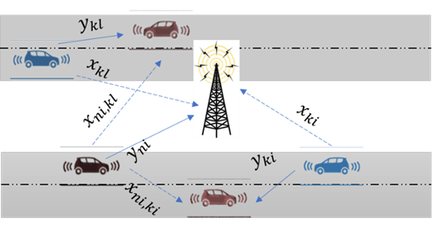

1. The investigated D2D-enabled V2X network.

Herein the system model is identified as an orthogonal frequency division multiple access (OFDMA) system as described in [18]. The available up-link bandwidth is divided into resource blocks (RB) with over each scheduling time unit. So, we call one sub-band over one scheduling time unit as one RB. For simplicity's sake, it is assumed that one RB can be allocated by at most one V2I and one V2V pair.

The channel between a V2V link is depicted as and the channel from the vehicle to the BS, which means V2I link, is illustrated by . Since D2D communications are assumed, the network is suffered from the interference channels. The interference link between the V2I transmitter and the V2V receiver is denoted by . Also, the interference link from the V2V transmitter to the BS is indicated by .

So, can be written as

|  |  |
| --- | --- |
|  | (1) |

where is the small-scale fast fading and its components are i.i.d. random variables as .Also, is the large-scale fading. Based on essential requirements to address reliability, outage probability is represented by

|  |  |
| --- | --- |
|  | (2) |

where *F* is the minimum threshold to verify reliable links. and are the transmit power of the *ni*th V2V and *ki*th V2I, respectively. , , and *Z* are the noise power, the maximum outage probability, and a binary variable, respectively. demonstrates that the spectrum of the *ni*th V2I is reused by the *ki*th V2V and otherwise.

The received SINR can be calculated as

|  |  |
| --- | --- |
|  | (3) |

As already stated, the main purpose of this study is to maximize the total throughput of V2Is while satisfying the V2Vs reliability and also assuring the minimum certain QoS of each V2I so that a minimum capacity requirement can be get by each of them. As it is vital to consume less transmitter power, it is also taken into consideration.

Accordingly, the optimization problem can be formulated as

|  |  |
| --- | --- |
|  | (4) |

subject to

|  |  |
| --- | --- |
|  | (5) |
|  | (6) |
|  | (7) |
|  | (8) |
|  | (9) |
|  | (10) |

where and are the maximum transmit powers of the V2Is and V2Vs, respectively. is the maximum transmit power of the vehicles. is the minimum bandwidth efficiency. The constraint (5) shows that each RB can only be allocated to one V2V. (6) and (7) show the powers limitation of each V2V and V2I transmitter, respectively. The total used powers can be controlled by (8). (9) guarantees the minimum throughput of each V2I and (10) satisfies the reliability of each V2V.

Despite the fact that the optimization problem is an integer programming optimization problem but it is a NP-hard problem. Hence, we solve the proposed optimization problem using an approach which is investigated in [9]. Therefore, by decoupling the problem and assuming that the *ki*th V2V reuses the spectrum of the *ni*th V2I, the optimal powers of the V2I and V2V transmitters can be assigned. Furthermore, it is tried to assign RBs to V2Vs.

# Power Allocation Method

The proposed optimization problem can be rewritten as

|  |  |
| --- | --- |
|  | (11) |

subject to

|  |  |
| --- | --- |
|  | (12) |
|  | (13) |
|  | (14) |
|  | (15) |

As investigated in [9], the feasible regions of (12), (13), and (15) can be described as follows.

* Case I:

|  |  |
| --- | --- |
|  | (16) |

Case II:

|  |  |
| --- | --- |
|  | (17) |

So, the feasible regions can be derived as

|  |  |
| --- | --- |
|  | (18) |
|  | (19) |

The feasible regions can be acquired as

|  |  |
| --- | --- |
|  | (20) |
|  | (21) |

where, for perfect CSI strategy, is nearly one.

At ,the intersection of (18) and (19) can be arised. Hence, and can be calculated as

|  |  |
| --- | --- |
|  | (22) |
|  | (23) |

It is assumed that and for and , respectively. The feasible regions are depicted in Fig. 2 where is the frontier point.

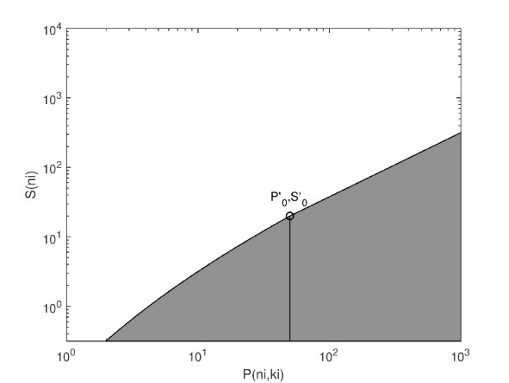

(a) Feasible region without constraint (14)

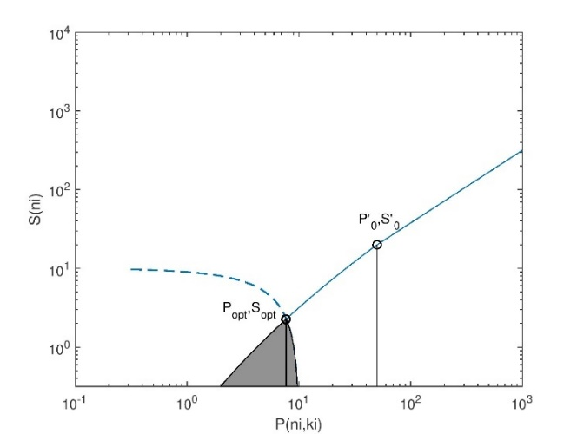

(b) Feasible region in case I

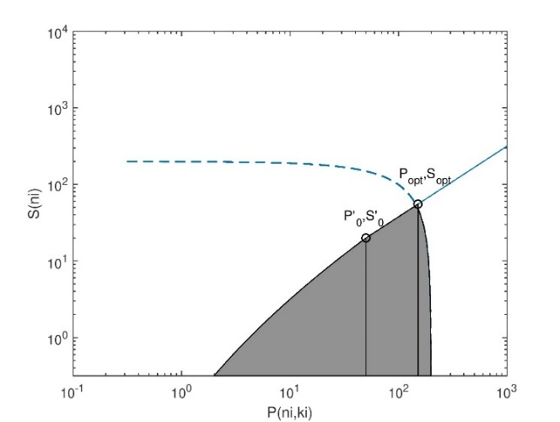

(c) Feasible region in case II

1. Feasible region.

# Performance Evaluation and Discussions

In this section, the performance of the presented algorithm is evaluated. We pursue the simulation setup based on the freeway case in 3GPP TR 36.885 [17]. The vehicles are released based on a spatial Poisson process and the vehicles are chosen randomly.

Simulation parameters are summarized as follows. The cell radius is about 500*m*. The antenna height is 25*m* at the BS and 1.5*m* at each vehicle. The maximum transmit powers are with a carrier frequency of 2 GHz and the bandwidth is 10 MHz. The noise power is assumed to be -114*dBm*. The BS antenna gain and vehicles antenna gain are assumed to be 8*dBi* and 3*dBi*, respectively.

Fig. 3 demonstrates the cumulative distribution function (CDF) of the total spectral efficiency of a V2V with a delayed CSI method presented in [9] and also with a perfect CSI. It is observed from the figure that with probability of 80%, the received spectral efficiency of V2V is less than 5.597 bps/Hz and 2.065 bps/Hz for perfect and partial CSI, respectively.

Fig. 4 illustrates the total spectral efficiency of the V2Is versus different velocity. From this figure, we can see that the spectral efficiency decreases as the velocity increases. In case partial CSI, 100 Km/h velocity results in 238.1 bps/Hz total received spectral efficiency of the V2Is. It is increased to 245.9 bps/Hz in case perfect CSI.

The total spectral efficiency of the perfect and partial CSI versus the number of V2Is are depicted in Fig. 5. It can be observed that total spectral efficiency increases as the number of V2Is increases.

The total spectral efficiency of the V2Is versus the distance between the BS and highway is shown in Fig. 6. We can see that it decreases as the distance increases. In case partial CSI, 30 m distance results in 238.9 bps/Hz total received spectral efficiency of the V2Is. It is increased to 247 bps/Hz in case perfect CSI.

1. CDF of the total spectral efficiency of a V2V.



1. Total spectral efficiency of the V2Is versus different velocity.



1. Total spectral efficiency versus the number of V2Is.



1. Total spectral efficiency of the V2Is versus the distance between the BS and highway.

# Conclusion

In this paper, a D2D-enabled vehicular communication has been investigated and an optimal power allocation method has been studied. The studied method can maximize the total spectral efficiency of the model subject to satisfy some constraints. The performance of the investigated model has been shown when the CSI is perfectly known or not. It is observed that the performance of the system is degraded as the velocity increases. It is also degraded by increasing the distance between the BS and highway

##### References

1. B. Wang, R. Zhang, C. Chen, X. Cheng, L. Yang, and Y. Jin, “Interference hypergraph-based 3d matching resource allocation protocol for noma-v2x networks,” IEEE Access, vol. 7, pp. 90789–90800, 2019.
2. H. Xiao, Y. Hu, K. Yan, and S. Ouyang, “Power allocation and relay selection for multisource multirelay cooperative vehicular networks,” IEEE Transactions on Intelligent Transportation Systems, vol. 17, no. 11, pp. 3297–3305, 2016.
3. Hu, Xin, et al. "A joint power and bandwidth allocation method based on deep reinforcement learning for V2V communications in 5G." China Communications vol. 18, no. 7, pp. 25-35, 2021.
4. Sangsuwan, Nathat, and Settawit Poochaya. "The Study of Path Loss and Shadowing Effect in V2V Communication Link using 5G Communication Technology." 2021 9th International Electrical Engineering Congress (iEECON). IEEE, 2021.
5. Lee, JongKeun, and DaeIg Chang. "Performance comparison of V2V communication based on LTE-D2D with cooperative schemes." 2016 International Conference on Information and Communication Technology Convergence (ICTC). IEEE, 2016.
6. Mei, Jie, et al. "A latency and reliability guaranteed resource allocation scheme for LTE V2V communication systems." IEEE Transactions on Wireless Communications vol. 17, no. 6, pp. 3850-3860, 2018.
7. Singh, Anjali, and Brahmjit Singh. "A study of the IEEE802. 11p (WAVE) and LTE-V2V technologies for vehicular communication." 2020 International Conference on Computation, Automation and Knowledge Management (ICCAKM). IEEE, 2020.
8. Nguyen, Khoi Khac, et al. "Distributed deep deterministic policy gradient for power allocation control in D2D-based V2V communications." IEEE Access vol. 7, pp. 164533-164543, 2019.
9. Yue, Peng, Le Wu, and Zongmin Cui. "Integrating LTE-D2D and VLC techniques to support V2V communication." 2017 IEEE/CIC International Conference on Communications in China (ICCC). IEEE, 2017.
10. J. Cheng, H. Li, Y. X. Guo, H. Y. Li, and K. X. Xiao, “Power allocation and receiver design for d2d assisted cooperative relaying downlink system using noma,” IEEE Access, vol. 8, pp. 210663–210677, 2020.
11. J. Z. Moghaddam, M. Usman, and F. Granelli, “A device-to-device communication-based disaster response network,” IEEE Transactions on Cognitive Communications and Networking, vol. 4, no. 2, pp. 288–298, 2018.
12. Z. M. Bakhsh, J. Z. Moghaddam, and M. Ardebilipour, “An interference management approach for cr-assisted cooperative d2d communication,” AEU-International Journal of Electronics and Communications, vol. 115, p. 153026, 2020.
13. R. Atallah, M. Khabbaz, and C. Assi, “Energy harvesting in vehicular networks: A contemporary survey,” IEEE Wireless Communications, vol. 23, no. 2, pp. 70–77, 2016.
14. W. Sun, D. Yuan, E. G. Str¨om, and F. Br¨annstr¨om, “Cluster-based radio resource management for d2d-supported safety-critical v2x communications,” IEEE Transactions on Wireless Communications, vol. 15, no. 4, pp. 2756–2769, 2015.
15. C. Chen, B. Wang, and R. Zhang, “Interference hypergraph-based resource allocation (ihg-ra) for noma-integrated v2x networks,” IEEE Internet of Things Journal, vol. 6, no. 1, pp. 161–170, 2018.
16. L. Liang, J. Kim, S. C. Jha, K. Sivanesan, and G. Y. Li, “Spectrum and power allocation for vehicular communications with delayed csi feedback,” IEEE Wireless Communications Letters, vol. 6, no. 4, pp. 458–461, 2017.
17. 3GPP, “3rd generation partnership project; technical specification group radio access network; study on lte-based v2x services; (release 14), tr 36.885 v2.0.0,” Jun 2016.
18. S. Kadloor and R. Adve, “Relay selection and power allocation in cooperative cellular networks,” IEEE Transactions on Wireless Communications, vol. 9, no. 5, pp. 1676–1685, 2010